Java Training Day-1

\\172.16.1.59\Training

To check whether the network folder is connected or not

We can ping in command prompt using the ip address of the network

Win+r

cmd

//source drive/ping ip address

C: training/ping 172.168.1.1

DAY-1 AGENDA

JAVA --> JEE --> FRAMEWORK --> SPRING --> SPRING BOOT

DATABASE

Open Database --> My SQL (Free/open source)

SUN TECHNOLOGIES (James Gosling) --> Oracle

1. JSE --> Java Standard Edition (Core Java)

2. JEE --> Java Enterprise Edition (Advance Java)

3. J2ME --> Java Micro Edition (Mobile)

4. JFX

JDK 17 is the latest version released on Sep 14 2021

--> JDK stands for Java Development Kit

For training purpose we are using JDK 1.8 which is free ware version

Installing JDK

JDK

JRE (Java Run time Environment)

To run java in the computer we need the java runtime environment

* HLL High level language (Human)

Translator

1. Compiler

Execute the entire code and translate

2. Interpreter

Line by line translate

* LLL Low level language
  + Example: Machine and Assembly code. Programming language that provides little or no abstraction from a computer's instruction set architecture—commands or functions in the language map closely to processor instructions.

JSE

Java standard edition having both the compiler and Interpreter. Translator (Interpreter (command-> java) + Compiler (command-> javac))

To check the version of JSE installed in the system

Step1: win+r

cmd

Step2: java -version

javac -version

If JDK is not installed, install the JDK (C:\Program Files\Java --> default location)

Step3: Configure in environment variable

Edit system variables

Advanced

Environment Variables

Path --> Edit

1) Path = location of jdk\bin (ex: C:\Program Files\Java\bin) Need to move up to give the priority to java.

This will be achieved my pressing Home key on keyboard and need to paste the path.

2) JAVA_HOME = location of jdk

New --> Variable name: JAVA_HOME

Path: C:\Program Files\Java

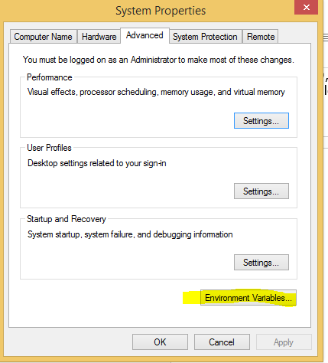 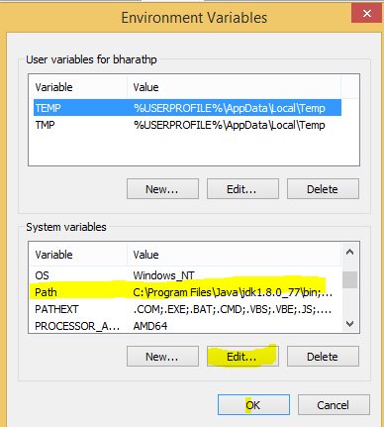 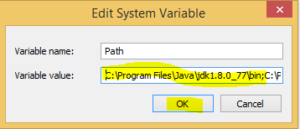 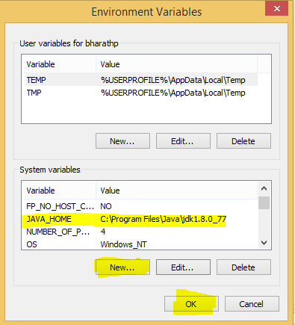

Step 4: Software

1. To work with the java we need a text editor (Notepad)
2. CLI (Command Line Interface)
3. IDE Integrated Development Environment
   1. There are lot of IDE’s where we can run java programs and create the java projects.
   2. Some of the IDE’s are
      1. ECLIPSE
      2. STS (Spring Tool)
      3. INTELLIJ

--> Once the code is written, need to save it with the name which is same name of the class that written in the code with the extension .java in the desired folder.

--> Then type cmd in the desired folder path bar which will redirect to the command prompt with the desired path

As we know first we need to compile the java file

In command prompt type javac <filename with the extension> then press enter

Example: D: Training/JavaDemos> javac Hello.java

Java compiler compiles the java file and creates the Java class file which we call it as a java byte code which will be further interpreted by java interpreter

Type java <filename without extension>

Example: D: Training/JavaDemos> java Hello

Then the desired output can be seen in the command Prompt

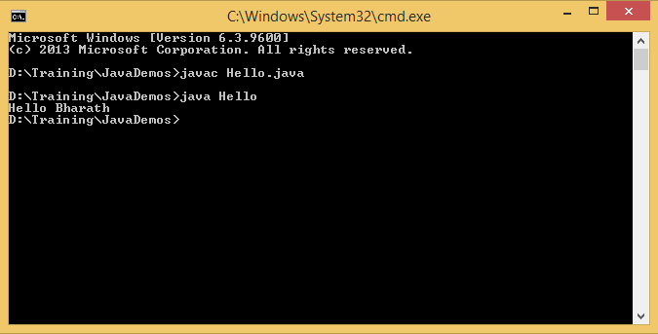

Hello world Program

public class HelloWorld{

public static void main(String args[]){

System.out.println ("Hello World")

}

}

// public is an access modifier. Which will give the access to the class. Public, Private, Protected are the access modifiers

// class is a keyword to define the class HelloWorld

// HelloWorld is the class name. The same name should be given to the file with the extension of .java

// main () is the method from which the methods of the class will be called. It’s like a door to enter into the class

// System.out.println command will print the "Hello World" string in the console

Anything quoted in “” is a String In java. String is an object in java

Coding Standards

* Variable name or method name should start with small letter and must follow the camel case (first letter will be small and the continuing names first letter will start with capital. Ex: myArray, nameOfTheMethod
* Every class name or Interface must start with the capital letter and follow the pascal case naming convention. Ex: HelloWorld, MyClass
* Java is case-sensitive: "MyClass" and "myclass" has different meaning.
* Names can contain letters, digits, underscores, and dollar signs
* Names must begin with a letter
* Names should start with a lowercase letter and it cannot contain whitespace
* Names can also begin with $ and _

Predefined Classes == API 🡪 Application Program Interfaces

* String
* System

Data Types

* Primitive Data Types (8 data types in java)
  + Byte (0/1) which will machine understand stores whole numbers from -128 to 127
  + Short stores whole numbers from 32,768 to 32,767
  + Int stores whole numbers from -2,147,483,648 to 2,147,483,647
  + Long stores whole numbers from -9,223,372,036,854,775,808 to 9,223,372,036,854,775,807
  + Float Sufficient for storing 6 to 7 decimal digits
    - float floatVariable= 12.5f
    - Why should we suffix it with f
    - If we not suffix with f by default it will consider as double
      * Memory allocation
        + Float: 4 bytes (32 bit)
        + Double: 8 bytes (64 bit)
        + Int: 4 bytes (32 bit)
        + Short: 2 bytes (16 bit)
        + Long : 8 bytes (64 bit)
        + Byte: 2 bytes (16 bit)
  + Double
  + Char
  + Boolean
* Derived Data Types (Deriving from already existing data types)
  + Array [ ]
    - Collection of similar data types
    - Continuous memory allocation
    - Access sequential with help of index position
    - Example
      * Int [] a = {10,20,30} 🡪 java
      * Int a[] = {10,20,30} -> c
      * Float[] variableName = {1.2f,2.5f,5.7f}
      * char[] charecterArray = {‘a’, ‘b’,’c’}
      * byte[] anArrayOfBytes;
      * short[] anArrayOfShorts;
      * long[] anArrayOfLongs;
      * double[] anArrayOfDoubles;
      * boolean[] anArrayOfBooleans;
      * char[] anArrayOfChars;
      * String[] anArrayOfStrings;
    - Multi-dimensional array [][]
      * Example
      * String[][] names = {{"Mr. ", "Mrs. ", "Ms. "}, {"Smith", "Jones"}};
  + Enum
* User defined / Developer (store multiple data type) / Class / Blue print / Template
  + Example in C, C++

Struct Employee{

Int empId;

Char name[];

Float salary;

}obj1,obj2;

Obj1.empId=10;

Obj1.name=”Bharath”;

Obj1.salary=10000.00;

* + Example in Java

class Employee{

Int empId;

Char name[];

Float salary;

}

Employee obj1 = new Employee();

Employee obj2 = new Employee();

Program Example with the above data types

class Hello{

public static void main(String[] args){

System.out.println("Hello Bharath, Here's the result of your code");

int a=10;

int b=20;

System.out.println("Value in a: "+a);

System.out.println("Value in b: "+b);

System.out.println("Value of a+b: "+ (a+b) ); //BODMAS

int[] myArray = {10,20,30,40,50,60,100,45};

System.out.println("Length of the array: "+ myArray.length);

System.out.println("Number in the zeroth index is: "+ myArray[0]);

System.out.println("Number in the second index is: "+ myArray[2]);

System.out.println("Sum of the numbers in array is: "+(myArray[0]+myArray[1]+myArray[2]+myArray[3]+myArray[4]+myArray[5]+myArray[6]+myArray[7]));

char[] charecterArray = {'a', 'b','c','d'};

System.out.println("Length of the charecter array: "+ charecterArray.length);

System.out.println("Char in the zeroth index is: "+ charecterArray[0]);

float floatVariable= 12.5f; // with or without the decimal point

float[] floatValuesArray = {12.5f, 25.8f, 3.485f, 5.89f, 25.0f};

System.out.println("Float in the zeroth index is: "+ floatVariable[0]);

}

} //body of the code --> comment

Looping Statements

* + For (init; cond; incre || decre){}
    - Ex: for (**int** i = 0; i < 5; i++){}
    - i++ Post Increment
    - ++i Pre Increment
  + While
  + Do While

Conditional Statements

* + If else
  + If else if else

Program Example with the for while and do while loops

**public** **class** Demo1 {

**public** **static** **void** main(String[] args) {

**int**[] myArray = { 1, 2, 3, 4, 5, 6 };

// While loop

**int** x = 0; // Initialization

**while** (x < myArray.length) { // condition

System.***out***.println(myArray[x]);

x++; // Updating

}

// For loop

**int** j = 0; // Initialization

**for** (**int** i = 0; i < myArray.length; i++) { // condition

j = j + myArray[i];

}

System.***out***.println(j);

// Enhanced for loop

**for** (**int** z : myArray) {

System.***out***.println(z);

}

}

}

Comments in Java

* + // Single line comment
  + /* */ Multiline Comments
  + /** Doc comment

Scope

* + Local Variable
    - Accessible within the functions or methods
  + Global Variable
    - Accessible in the entire code